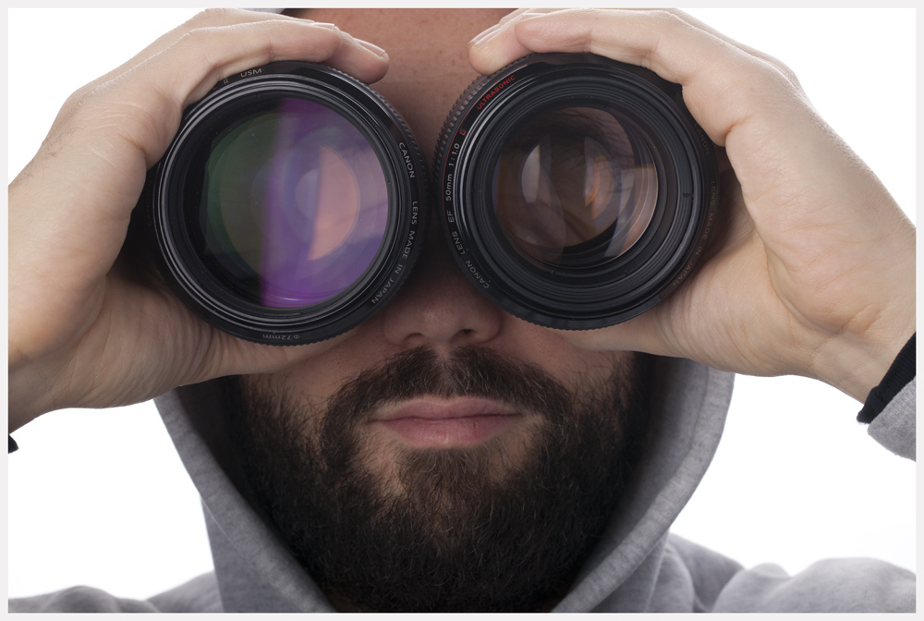

Bringing humor and creativity into a piece of art can really make for an interesting piece. I am not sure if humor was the purpose of this piece, but the use of the lenses bring held over his eyes almost reminds me of the bug eyes of a fly. If you look carefully through the lenses the eyes aren't visible but the eyebrows are, and significantly magnified. The texture of the bears beings another level of interest into this piece as it breaks up the man's face, especially since his hairline isn't visible causing a lack of texture. This is overall an interesting piece, but its simplicity really doesn't hold the viewer for very long.